Lab Exercise 16- Remotely Build with Parameters in Jenkins

Aim
To configure a Jenkins job that accepts user-defined parameters at build time and uses those parameters during the build execution.

Objectives
After completing this lab, students will be able to:
- Configure a Jenkins job with parameters
- Understand different parameter types
- Trigger builds using Build with Parameters
- Use parameters inside shell scripts
- Observe dynamic build behavior based on user input

Prerequisites
- Jenkins installed and running
- Access to Jenkins web UI
- Basic Linux shell knowledge
- Git installed (optional)

Tools Required
- Jenkins
- Web browser
- Linux shell (built-in Jenkins shell step)

Concept Overview
What is Build with Parameters?
Build with Parameters allows users to:
- Pass inputs (like environment, version, flags)
- Control build behavior dynamically
- Reuse the same job for multiple scenarios

Common Use Cases
- Deploy to dev / test / prod
- Select application version
- Enable or disable tests
- Choose branch names

Step 1: Create a New Jenkins Job
- Open Jenkins dashboard
- Click New Item
- Enter job name:
parameterized-build-demo
- Select Freestyle project
- Click OK

Step 2: Enable “This project is parameterized”
- In job configuration, check:
This project is parameterized
You will now see Add Parameter options.

Step 3: Add String Parameter
- Click Add Parameter → String Parameter
- Configure:
  - Name: APP_VERSION
  - Default Value: 1.0.0
  - Description: Application version to build

Step 4: Add Choice Parameter
- Click Add Parameter → Choice Parameter
- Configure:
  - Name: ENVIRONMENT
  - Choices:
  - dev
  - test
  - prod
  - Description: Deployment environment

Step 5: Add Boolean Parameter
- Click Add Parameter → Boolean Parameter
- Configure:
  - Name: RUN_TESTS
  - Default Value: Checked
  - Description: Run test cases during build

Step 6: Add Build Step
- Scroll to Build
- Click Add build step → Execute shell
- Add the following script:

echo "Starting Build"
echo "Application Version: $APP_VERSION"
echo "Environment: $ENVIRONMENT"

if [ "$RUN_TESTS" = true ]; then
echo "Running test cases..."
else
echo "Skipping tests..."
fi

echo "Build completed successfully"

Step 7: Save the Job
Click Save

Step 8: Build with Parameters
- From job dashboard, click:
Build with Parameters

- Provide values:
  - APP_VERSION → 2.1.0
  - ENVIRONMENT → test
  - RUN_TESTS → Checked / Unchecked
- Click Build

Step 9: Verify Console Output
- Click the build number
- Open Console Output
Sample Output
Starting Build
Application Version: 2.1.0
Environment: test
Running test cases...
Build completed successfully

Step 10: Build Remotely
- Job must be parameterized
  - Example parameters:
    - ENV
    - VERSION
    - RUN_TESTS
- Remote trigger enabled
  - Job → Configure
  - Check: Trigger builds remotely
  - Set an Authentication Token, e.g.
mytoken123
- You need Jenkins username + API token
  - Jenkins → User → Configure → API Token
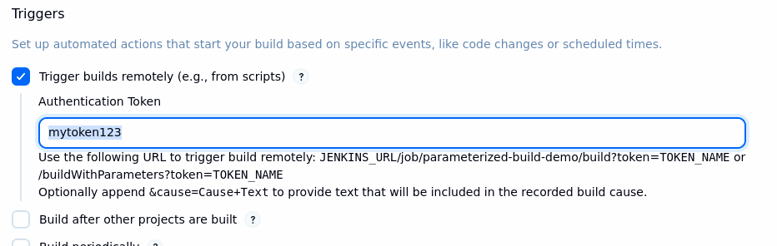

Basic Remote Build (No Parameters)
Example:
curl -X GET http://localhost:8080/job/parameterized-build-demo/buildWithParameters?token=mytoken123

Remote Build WITH Parameters (Most Common)
Use buildWithParameters
curl -X GET "http://localhost:8080/job/parameterized-build-demo/buildWithParameters?token=mytoken123&ENVIRONMENT=prod&APP_VERSION=2.3.1&RUN_TESTS=false"

